**The Ecological and Social Impacts of Ineffective Heating**

**Date:** 2023/03/08

**Name:** Tomás Belmar da Costa

**Course:** AL1523 Digitalization and Innovation for Sustainable Development

**Summary (~150 words)**

**Introduction**

Heating systems have been an integral part of human society, as well as a necessity, especially in colder regions such as Sweden. However, the way in which we heat our homes, offices, and buildings in general has had significant negative impacts on the environment and contributed to climate change. One of the leading issues regarding heating is the sheer amount of wasted energy that comes with poorly designed and managed heating systems.

The International Energy Agency has estimated that around half of all energy demand for buildings in 2021 was used for space and water heating. [CITE] Not only does this constitute an enormous amount of energy waste, but also directly leads to 2450 megatons of CO2 emissions. The agency speaks about how fossil fuels still (written in 2021) correspond to over 60% of the heating energy demand, showing how ineffective and unrenewable heating practices are in our modern day world.

Considering sustainability issues other than just the environmental consequences of heating, higher energy waste directly leads to higher energy costs. While this consequence impacts businesses and building owners, a lesser talked about impact is how poor communities deal with these issues, especially in locations where heating is a necessity and not just a luxury. [CITE]

In this report, we will focus on the issue of energy waste caused by unsustainable heating practices. Specifically, we will examine what solutions digitalization can provide that will allow us to minimize energy waste in the heat sector. By addressing this issue, we can significantly reduce the carbon footprint of buildings and specifically focus on the United Nations Sustainable Development goals three and six, from a social justice perspective, and goals seven, eleven, and thirteen, from a climate justice perspective. [CITE]

**Aim**

The overall aim of this report is to explore the possibilities of digitalization in reducing energy waste associated with poor and modern heating practices. Specifically, I aim to identify the benefits of using digital technologies such as sensors and thermostats, coupled with energy management systems, in order to optimize heating performance, ensuring minimal energy usage when directly compared to amount of heating done in a building.

This report will not only have to assess the main shortcomings and causes of energy waste when relating to heating, but also the negatives involved with the proposed digitalization solution to this problem. I will measure the environmental and social consequences that implementing heating sensors and digitally managing the heating system may have. These consequences may be in the form of more energy usage by the sensors, system failures, and many other ways [CITE]. Regardless, these are potential consequences that may not be ignored, and for which we must weigh the costs and benefits.

Overall, the report should give a reasonable set of guidelines on the main causes of unsustainable heating, as well as how building owners and planners may address these issues to not only help them save costs, but also waste less energy and emit less carbon emissions.

**Sustainability Challenge (~800 words)**

Despite being such a crucial aspect of our lives, the way in which we heat our buildings and homes has had and continues to have significant negative impacts on sustainable development goals, both national and international. The United Kingdom’s Department for Energy Security and Net Zero has estimated that globally, heat accounts for nearly half of all energy consumption, and about 40% of energy-related carbon dioxide emissions [CITE]. Considering that fact, as well as the graph shown at lecture three of the course that details how much carbon dioxide is in our atmosphere compared to throughout earth’s history, it’s clear why this 40% is so significant.

Figure 1: Atmospheric CO2 concentration from the Vostok ice core record. Taken from lecture 3.

The releases of these greenhouse gases into the atmosphere has resulted in a steady increase in global temperatures, which is partly (and largely) responsible for the claim that combined land and ocean temperature has increased at an average of 0.08 degrees Celsius per decade since 1880 [CITE]. That means about 1.12 degrees Celsius in total, and projected to get worse. Keeping in mind the UNSD (United Nations Sustainable Development) goals mentioned in lecture eight, goal number thirteen details climate action, which heating is, as shown, directly contrasting with. Considering the idea of a doughnut economy proposed by Kate Raworth, heating has affected and contributed to humanity’s “overshooting” on several of the planetary boundary categories, such as land-system change, stratospheric ozone depletion, climate change, and biosphere integrity. While none of these categories are yet on the “red” high risk zone, they are largely on the “yellow” uncertainty zone and, with exception to the ozone depletion, have been steadily rising.

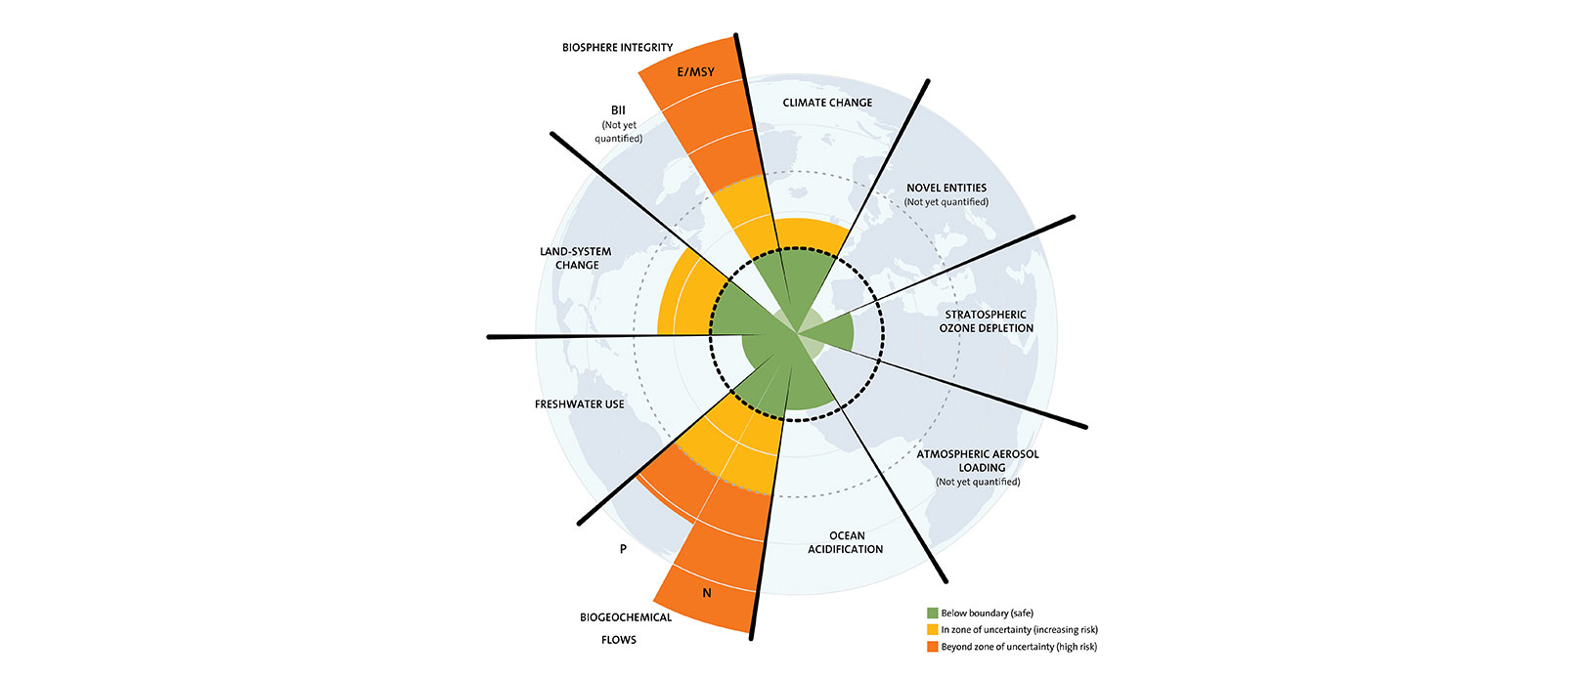

Figure 2: The nine planetary boundaries

A lot of the issues caused by heating directly correlate to a misuse of it. By and large, when society is building itself, it doesn’t consider how their buildings and spaces will accommodate heating as a first priority. Despite efforts to do so in recent history, the way buildings trap heat and allocate heating is in several ways ineffective [CITE]. This leads to a direct huge amount of energy waste regarding heating, in direct contrast with the UNSD goal number eleven (sustainable cities and communities). The government of Sweden has recognized this issue, and vowed to lead “society's transition to a sustainable energy system” funding national research on renewable energy technologies, smart grids, vehicles, and more [CITE].

This energy waste of course is one large reason why the aforementioned problems are so prevalent, but a lesser talked about issue is the social impact this has. When people pay for heating, they’re essentially paying for energy usage. Higher energy usage directly correlated with higher heating prices, and that’s exactly what happens in society. While of course this has an effect on building owners and landlords, the most affected group are those in the lower end of society who can no longer afford heating. Heating is a necessity, especially in colder countries such as Sweden, and especially if you don’t have a permanent shelter. Because of this, high heating prices directly affect a decently sized chunk of the population that must then resort to other means, which directly clashes with the UN’s sustainable development goal seven (affordable and clean energy), ten (reduced inequalities).

The wider system impacts of this sustainability challenge are far and wide. As was mentioned already, many of the poorer ends of society suffer largely from not having access to heating. Lecture eleven provides us with a perfect graphical representation of how energy deprived some societies, specifically the poorer people in those societies, are.

Figure 3: Global map of energy poverty from 2018.

While this map doesn’t directly mention anything about heating, it gives a general overview of how the energy demand is not being met in several parts of the world, a large part of which constitutes of heating. Because of this, in countries and regions where heating is more of a necessity than a luxury, society has to adapt. This leads to examples of “makeshift” heating. Burning tires, plastic, fossil fuels, and other objects in order to stay warm during a cold winter [CITE]. The direct consequence of this is an ineffective method of heating and more greenhouse gases released onto the atmosphere. Furthermore, the inhalation of these toxic materials by the people who have to rely on this type of heating causes a myriad of health problems for them. The US department of health’s Environmental Health Perspectives division estimates that “exposure to household air pollution (HAP) from inefficient biomass and coal stoves kills nearly 4 million people every year worldwide” [CITE]. Not to mention that burning all these objects may be expensive, and therefore at times not even an option, or when it becomes an option may otherwise economically hinder people who are already greatly affected by poverty.

A smaller, but existent, positive system impact that comes with all of this is an incentive to tear down old buildings. Since old buildings were built without heating in mind, it becomes more expensive for building owners to maintain them. This causes an incentive for refurbishing or rebuilding them, which coupled with modern building practices leads to more sustainable buildings, in line with UNSD goal number eleven (sustainable cities and communities). This may pave way for greener communities all around, and may leak over to areas other than just heating and energy.

* Description of Sustainability Challenge (400 words)
  + More in depth than introduction
  + Negative environmental and social sustainability impacts and what causes those impacts
  + Specific examples of how this affects national and international goals for sustainable development
* Wider system impacts of the sustainability challenge (400 words)
  + Side effects of the positive and negative impacts (unintended consequences)
  + Analyze the social and environmental consequences with this in mind
  + Concepts from the course
    - Goal conflicts
    - Life cycle impacts
    - Global vs Local effects
* QUOTE THE COURSE (4 lectures, 3 simple 1 complicated)
  + Lecture 2 (Planetary boundaries)
  + Lecture 3 (Introduction to sustainable development)
  + Lecture 8 (Environmental sustainable development challenges, trends, goals)
  + Lecture 11 (Energy sector)

**Digitalization as a Solution (~800 words)**

* One digitalization solution to heating (150 words)
* How does this digitalization solution function, what does it mean in order to reduce the environmental and/or social sustainability problems (150 words)
  + Use terminology from Hilty & Aebischer's framework (presented in Lecture 4 "Digitalization and sustainable development")
* Positive and negative unintended consequences from implementing this solution (300 words)
* Basic innovation theory to explain how this may be a welcome solution in ways other than in the sustainability aspect (300 words)
* QUOTE THE COURSE (3 lectures, 2 simple 1 complicated)
  + Lecture 4 (Digitalization and sustainable development)
  + Lecture 9 (Circular economy and Life cycle perspective)
  + Lecture 10 (Social sustainable development challenges, trends, goals)
  + Lecture 12 (Building sector)

**Reflection (~250 words)**

**References**

[https://www-sciencedirect-com.focus.lib.kth.se/science/article/pii/S0959652620350800](https://www-sciencedirect-com.focus.lib.kth.se/science/article/pii/S0959652620350800#bib14)

<https://www-sciencedirect-com.focus.lib.kth.se/science/article/pii/S0360544217312124>

IEA (2022), Heating, IEA, Paris https://www.iea.org/reports/heating, License: CC BY 4.0

Landi G, Granata V, Germano R, Pagano S, Barone C. Low-Power and Eco-Friendly Temperature Sensor Based on Gelatin Nanocomposite. Nanomaterials. 2022; 12(13):2227. <https://doi.org/10.3390/nano12132227>

<https://www-sciencedirect-com.focus.lib.kth.se/science/article/pii/S1364032120309850>

<https://www.ncbi.nlm.nih.gov/pmc/articles/PMC8776175/>

<https://www-sciencedirect-com.focus.lib.kth.se/science/article/pii/S0959652620350800>

<https://www.gov.uk/government/publications/international-comparisons-of-heating-cooling-and-heat-decarbonisation-policies>

<https://www.ncei.noaa.gov/access/monitoring/monthly-report/global/202113>

<https://www.government.se/government-policy/the-global-goals-and-the-2030-Agenda-for-sustainable-development/>

<https://www.energimyndigheten.se/en/>

<https://ehp.niehs.nih.gov/doi/10.1289/ehp.1306709>